**Web-Based Music Player Project Report**

**Project Title:** Web-Based Music Player Application

**Objective:**  
The project aims to develop a web-based music player using HTML, CSS, and JavaScript that allows users to play audio files through a clean and interactive interface. It provides hands-on experience in building user-friendly web applications.

**Project Description:**  
The web-based music player is designed to offer a seamless audio playback experience. Users can play, pause, skip songs, adjust volume, and navigate through a playlist. The interface is responsive and visually appealing.

**Technologies Used:**

* HTML5 (for structuring the player)
* CSS3 (for styling and responsive design)
* JavaScript (for functionality and interactivity)

**Features:**

1. **User Interface:**
   * Clean and intuitive layout.
   * Play, pause, previous, and next buttons.
   * Progress bar for seeking songs.
   * Volume control slider.
2. **Audio Playback:**
   * Uses HTML5 <audio> element to play songs.
   * Supports multiple audio files.
3. **Playlist:**
   * Allows multiple songs to be added.
   * Users can click on a song in the playlist to play it.
4. **Play, Pause, and Seek:**
   * Play and pause controls.
   * Users can drag the progress bar to seek different parts of the song.
5. **Volume Control:**
   * Slider to adjust volume from 0 to 100%.
6. **Song Information:**
   * Displays current song's title and artist.
7. **Responsive Design:**
   * Works well on different screen sizes.

**Project Structure:**

music-player/

│── index.html

│── style.css

│── script.js

│── songs/

├── song1.mp3

├── song2.mp3

└── song3.mp3

**Code Snippets:**

1. **HTML:**

<audio id="audio" src="songs/song1.mp3"></audio>

<h2 id="song-title">Song Title</h2>

<h4 id="song-artist">Artist Name</h4>

1. **CSS (example):**

#song-title {

color: #ff4081;

}

#song-artist {

color: #00ffcc;

}

1. **JavaScript (play/pause functionality):**

const playBtn = document.getElementById("play");

const audio = document.getElementById("audio");

playBtn.addEventListener("click", () => {

if (audio.paused) {

audio.play();

playBtn.textContent = "⏸";

} else {

audio.pause();

playBtn.textContent = "▶";

}

});

**User Instructions:**

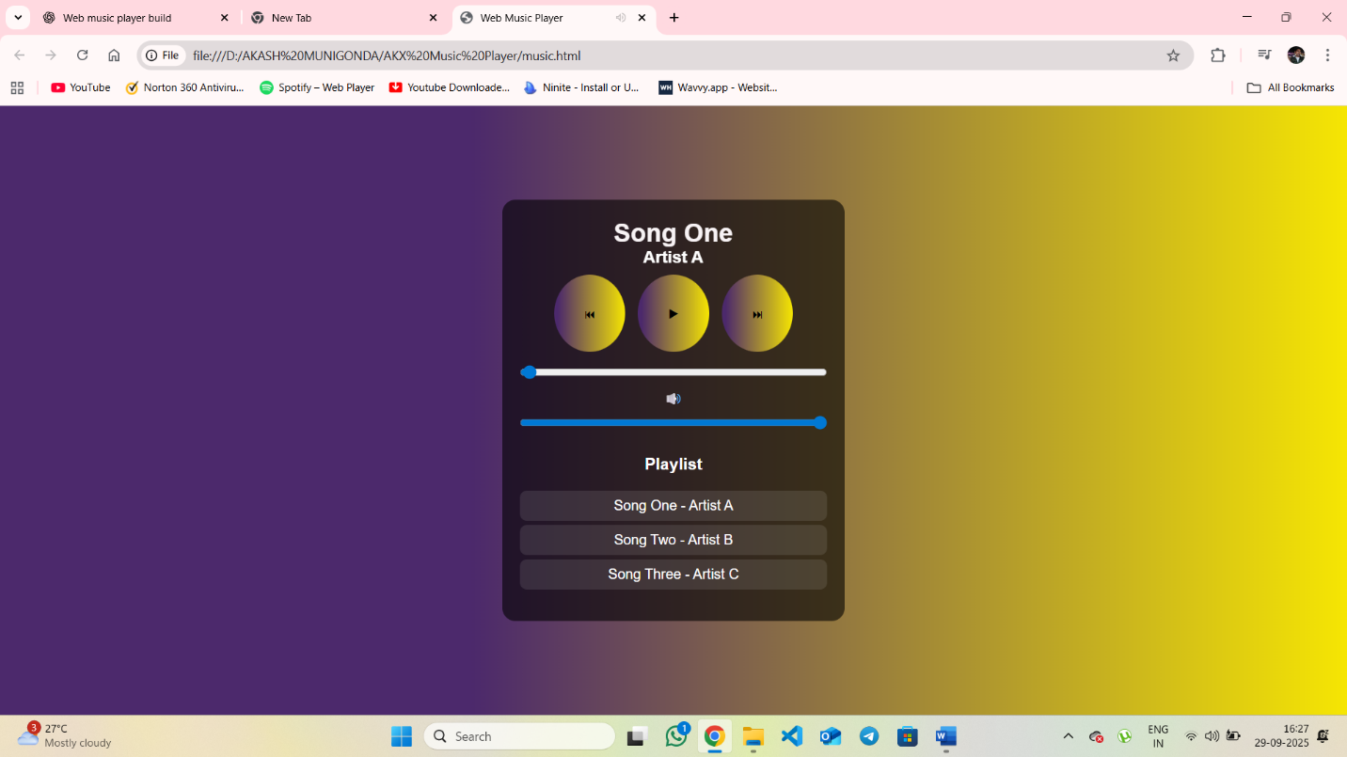

Open index.html in a web browser.

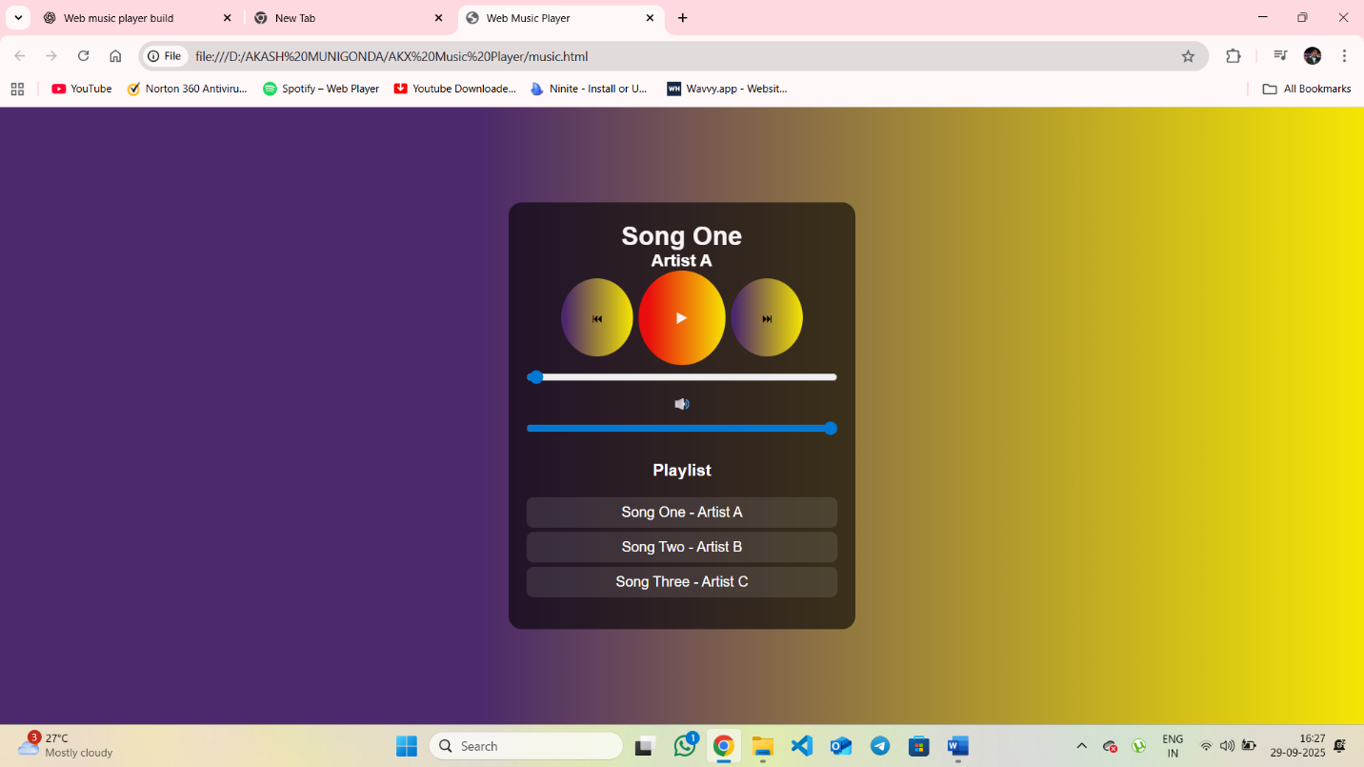

Use the play, pause, next, and previous buttons to control playback.

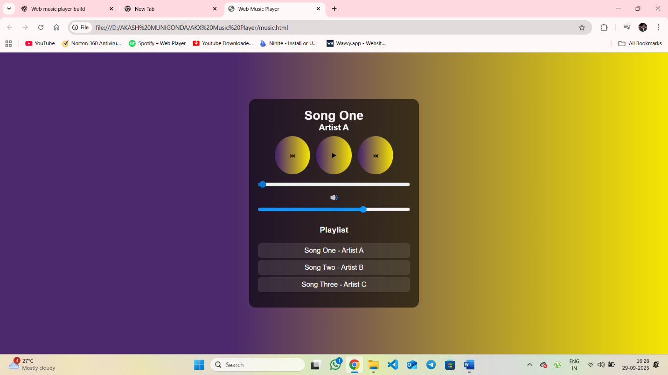

Adjust the volume using the slider.

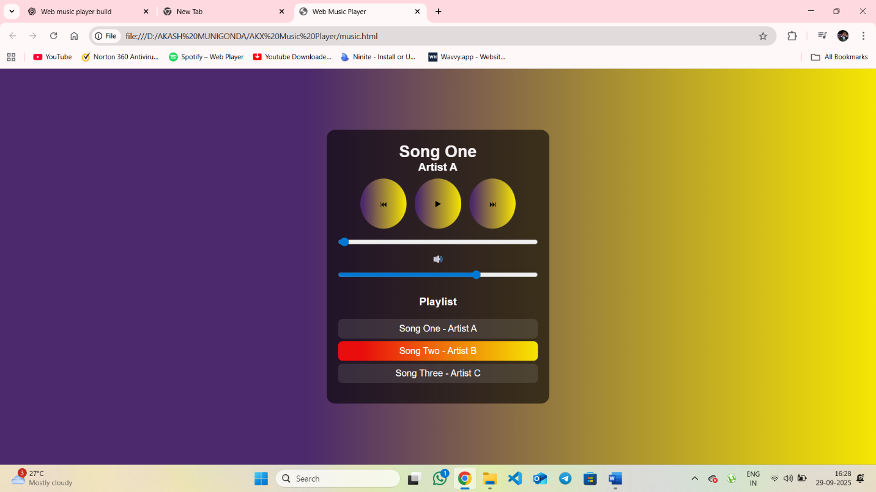

Click on a song in the playlist to play it.

**Conclusion:**  
The web-based music player successfully demonstrates audio playback functionality with a clean user interface. Users can easily navigate the playlist, control playback, and enjoy a responsive design. This project provides practical experience in integrating HTML, CSS, and JavaScript for interactive web applications.